Under Campus Instruction Beta
Click on Standardized Test, then click on the appropriate section and then choose assessment (pre or post) Enter score and click save.
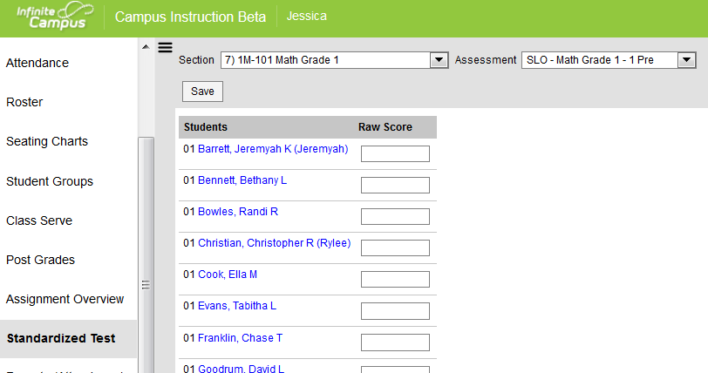

High School:
Teachers will need to enter pre & post scores under standardized test area. To have post score count 20% of final grade, teachers will also need to enter the post score under grading task called SLO just like EOCT scores are entered. This grading task will be added in the coming months.

